- Do not edit/delete any heading or section with red text.
- Type /paste you answers in relevant sections (below Final Answer (in all questions , Approach (wherever required ) and Charts & tables (wherever required)) of the solution
- Link to submission guidelines
- Please note that submission not following the guidelines will not be accepted

OBJECTIVE QUESTIONS

Question 1: What is the total no. of tables present in the data?

Solution:

Final Answer (if any):
Total number of tables present in the data = 1

Approach (if any):
The dataset was reviewed, and it consists of a single table containing all call center records including call details, agent information, and customer data.

Charts & Tables (if any):
Table Name: Raw Data Table
Description: Contains all call center records used for analysis

Question 2: What is the total no. of attributes present in the data?

Solution:

Final Answer (if any):
Total number of attributes = 43

Approach (if any):
Counted the number of columns (attributes) in the dataset using header row.

Charts & Tables (if any):

Question 3: The data consists of some inconsistent and missing values so ensure that the data used for further analysis is cleaned.

Solution:

Final Answer (if any):
Data was cleaned by handling missing values and removing inconsistencies.

Approach (if any):
Removed blank/null values
Standardized date format
Checked duplicates
Cleaned rating & duration fields
Charts & Tables (if any):

Question 4: What is the change in daily call volume day by day and also find the average daily call volume.

Solution:

Final Answer (if any):
Average daily call volume = 246.03

Approach (if any):
Created pivot table
Rows → Date
Values → Call Count (SUM & AVERAGE)

Charts & Tables (if any):
- Table Name: Daily Call Volume Pivot
Chart Name : Daily call Trend
- Description: Shows daily call trend and average
 | Daily Call Volume
Date | COUNTA of CallSid | Daily Change
1/12/2023 | 228
2/12/2023 | 332 | 104
3/12/2023 | 383 | 51
4/12/2023 | 364 | -19
5/12/2023 | 253 | -111
6/12/2023 | 254 | 1
7/12/2023 | 254 | 0
8/12/2023 | 138 | -116
9/12/2023 | 288 | 150
10/12/2023 | 430 | 142
11/12/2023 | 424 | -6
12/12/2023 | 358 | -66
13/12/2023 | 348 | -10
14/12/2023 | 226 | -122
15/12/2023 | 276 | 50
16/12/2023 | 258 | -18
17/12/2023 | 185 | -73
18/12/2023 | 233 | 48
19/12/2023 | 209 | -24
20/12/2023 | 178 | -31
21/12/2023 | 159 | -19
22/12/2023 | 163 | 4
23/12/2023 | 241 | 78
24/12/2023 | 232 | -9
25/12/2023 | 258 | 26
26/12/2023 | 255 | -3
27/12/2023 | 242 | -13
28/12/2023 | 181 | -61
29/12/2023 | 260 | 79
30/12/2023 | 179 | -81
31/12/2023 | 158 | -21
1/1/2024 | 115 | -43
2/1/2024 | 196 | 81
3/1/2024 | 107 | -89
Grand Total | 8365
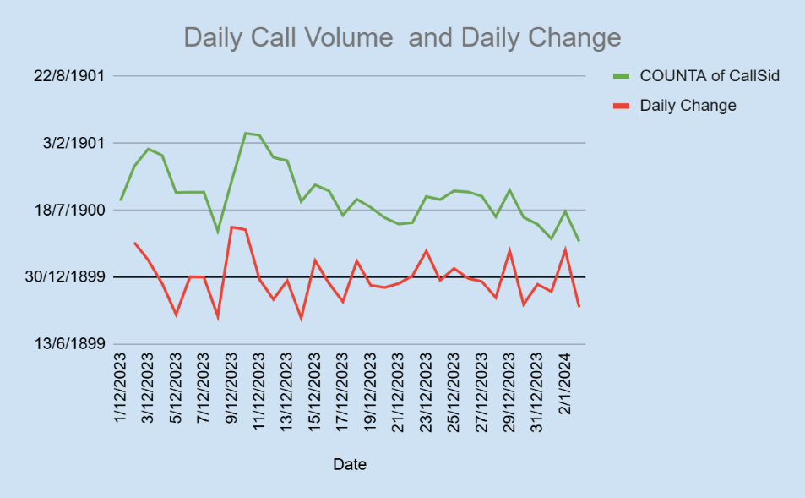

Question 5: Which months experienced the highest and lowest call volumes?

Solution:

Final Answer (if any):
• Highest month: December
• Lowest month: January
Approach (if any):
- Pivot → Monthly call volume

Charts & Tables (if any):
- Table / Chart Name:
Table Name: Total Calls
Chart Name – Monthly Call Volume
- Description:

This chart represents the total number of calls received in each month. It helps in identifying which month had the highest and lowest call volumes, allowing analysis of trends and seasonal variations in call center activity.
Month | Monthly Call Volume
Dec | 7947
Jan | 418
Grand Total | 8365

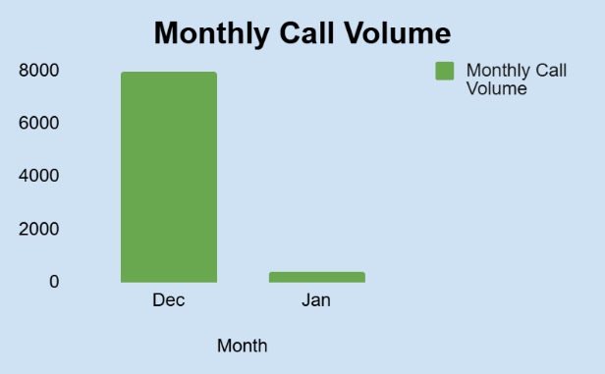

Question 6: What is the total operational cost for that month?

Solution:

Final Answer (if any):
Total operational cost for December month- 202239.21
Total operational cost for January month- 11826.69

Approach (if any):
- Used SUM of cost column

Charts & Tables (if any):
- Table Name:Operational cost
Chart Name : Monthly Revenue
- Description: This calculation represents the total operational cost incurred by the call center. It was computed by summing all cost-related values in the dataset, helping in understanding overall expenses and supporting profitability analysis.

Month | Operational cost
Dec | 202239.21
Jan | 11826.69
Grand Total | 214065.90
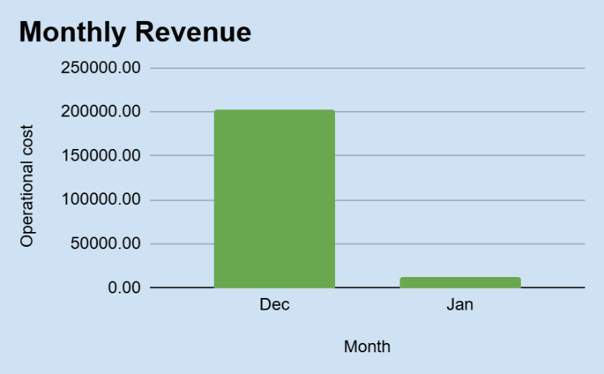

Question 7: What is the average number of calls handled per agent per day?

Solution:

Final Answer (if any):
Average calls handled per agent per day = 1.75

Approach (if any):
A Pivot Table was created to calculate the total number of calls handled by agents. The total calls were divided by the number of unique agents and then divided by the number of unique dates to calculate the average calls handled per agent per day.

- Formula Used : =Average Calls per Agent per Day =
Total Calls ÷ Unique Agents ÷ Unique Dates
- 8366 ÷ 133 ÷ 36 = 1.75

Charts & Tables (if any):
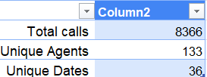

Question 8: How many repeat callers are there, and what percentage of total calls do they represent?

Solution:

Final Answer (if any):

Total repeat calls = 4737
Percentage of repeat calls = 57%

Approach (if any):
. A Pivot Table was created using uid (User ID) in Rows and Count of CallSid in Values to identify repeat callers.
Users with more than one call were considered repeat callers. A helper column named Repeat Calls was created using:
Count of CallSid - 1
This excluded the first call and counted only repeated calls.
The total repeat calls were then summed and divided by total calls to calculate the percentage of repeat calls.

Formula Used
Repeat Call Percentage =
Total Repeat Calls ÷ Total Calls × 100
Calculation:
4737 ÷ 8363 × 100 = 57%

Charts & Tables (if any):
- Table / Chart Name: Table Name:
Repeat Caller Analysis Pivot Table

Repeat Caller Analysis Pivot Table
Row Labels | Count of CallSid | Repeat Calls
437 | 9 | 8
511 | 2 | 1
543 | 6 | 5
787 | 20 | 19
1103 | 4 | 3
1105 | 6 | 5
1520 | 5 | 4
1555 | 2 | 1
1935 | 6 | 5
2044 | 15 | 14
2228 | 4 | 3
2329 | 10 | 9
2347 | 4 | 3
2394 | 10 | 9
2429 | 6 | 5
2727 | 2 | 1
2735 | 20 | 19
2887 | 7 | 6
2958 | 4 | 3
2986 | 11 | 10
3100 | 6 | 5
3615 | 10 | 9
4020 | 5 | 4
4071 | 6 | 5
4352 | 13 | 12
4529 | 5 | 4
4855 | 5 | 4
5065 | 2 | 1
5325 | 14 | 13
5337 | 2 | 1
5520 | 6 | 5
6018 | 2 | 1
6145 | 2 | 1
6146 | 10 | 9
6401 | 4 | 3
6633 | 2 | 1
7417 | 48 | 47
8031 | 14 | 13
8434 | 10 | 9
9512 | 14 | 13
9967 | 3 | 2
10327 | 19 | 18
10858 | 2 | 1
11154 | 21 | 20
11239 | 81 | 80
11336 | 8 | 7
11604 | 4 | 3
13013 | 3 | 2
13107 | 18 | 17
13172 | 4 | 3
13203 | 5 | 4
13303 | 2 | 1
13450 | 18 | 17
13928 | 3 | 2
14799 | 2 | 1
14817 | 2 | 1
15718 | 2 | 1
15903 | 14 | 13
16592 | 2 | 1
16606 | 16 | 15
17489 | 2 | 1
17696 | 74 | 73
18026 | 3 | 2
18974 | 3 | 2
19391 | 2 | 1
19533 | 7 | 6
19662 | 34 | 33
19880 | 3 | 2
20017 | 17 | 16
20046 | 2 | 1
20152 | 2 | 1
20170 | 6 | 5
20426 | 18 | 17
20758 | 2 | 1
20864 | 5 | 4
20993 | 4 | 3
21372 | 3 | 2
21477 | 5 | 4
21510 | 49 | 48
21544 | 4 | 3
21848 | 2 | 1
21912 | 8 | 7
21975 | 2 | 1
22032 | 15 | 14
22111 | 5 | 4
22203 | 59 | 58
22357 | 2 | 1
22609 | 2 | 1
22819 | 3 | 2
23348 | 4 | 3
23983 | 2 | 1
24645 | 6 | 5
25142 | 2 | 1
25435 | 54 | 53
25598 | 8 | 7
25757 | 3 | 2
25821 | 3 | 2
25917 | 3 | 2
26447 | 51 | 50
26624 | 5 | 4
26720 | 7 | 6
26968 | 6 | 5
27124 | 5 | 4
27297 | 3 | 2
27480 | 3 | 2
27964 | 9 | 8
28098 | 105 | 104
28285 | 83 | 82
28352 | 2 | 1
28371 | 2 | 1
28532 | 44 | 43
28570 | 2 | 1
28662 | 4 | 3
28940 | 3 | 2
28955 | 11 | 10
29021 | 3 | 2
29125 | 4 | 3
29287 | 2 | 1
29375 | 13 | 12
29558 | 7 | 6
29676 | 2 | 1
29681 | 2 | 1
29844 | 2 | 1
29892 | 2 | 1
29943 | 8 | 7
29961 | 6 | 5
30072 | 4 | 3
30100 | 4 | 3
30119 | 3 | 2
30141 | 7 | 6
30144 | 3 | 2
30158 | 5 | 4
30171 | 3 | 2
30181 | 7 | 6
30189 | 5 | 4
30190 | 4 | 3
30199 | 4 | 3
30201 | 2 | 1
30212 | 2 | 1
30231 | 4 | 3
30255 | 3 | 2
30261 | 4 | 3
30265 | 3 | 2
30282 | 4 | 3
30284 | 5 | 4
30295 | 2 | 1
30307 | 2 | 1
30310 | 3 | 2
30334 | 3 | 2
30386 | 3 | 2
30398 | 6 | 5
30407 | 3 | 2
30412 | 2 | 1
30415 | 2 | 1
30437 | 3 | 2
30438 | 2 | 1
30471 | 2 | 1
30478 | 28 | 27
30507 | 4 | 3
30519 | 4 | 3
30521 | 8 | 7
30524 | 2 | 1
30529 | 3 | 2
30530 | 2 | 1
30549 | 5 | 4
30567 | 9 | 8
30569 | 7 | 6
30578 | 2 | 1
30586 | 2 | 1
30596 | 3 | 2
30610 | 6 | 5
30613 | 6 | 5
30618 | 5 | 4
30619 | 5 | 4
30622 | 3 | 2
30634 | 5 | 4
30635 | 2 | 1
30641 | 3 | 2
30663 | 2 | 1
30670 | 6 | 5
30676 | 7 | 6
30679 | 2 | 1
30681 | 8 | 7
30682 | 2 | 1
30687 | 2 | 1
30689 | 2 | 1
30691 | 3 | 2
30698 | 4 | 3
30702 | 4 | 3
30709 | 2 | 1
30711 | 3 | 2
30718 | 4 | 3
30720 | 7 | 6
30721 | 4 | 3
30730 | 2 | 1
30732 | 2 | 1
30736 | 22 | 21
30738 | 33 | 32
30742 | 2 | 1
30746 | 2 | 1
30750 | 2 | 1
30752 | 5 | 4
30759 | 2 | 1
30764 | 6 | 5
30767 | 3 | 2
30772 | 12 | 11
30774 | 2 | 1
30781 | 5 | 4
30823 | 2 | 1
30830 | 5 | 4
30834 | 2 | 1
30838 | 8 | 7
30861 | 5 | 4
30890 | 4 | 3
30894 | 2 | 1
30901 | 4 | 3
30929 | 8 | 7
30932 | 3 | 2
30934 | 7 | 6
30964 | 6 | 5
30975 | 8 | 7
30977 | 2 | 1
30992 | 4 | 3
30998 | 22 | 21
30999 | 2 | 1
31005 | 7 | 6
31017 | 5 | 4
31033 | 2 | 1
31034 | 2 | 1
31039 | 5 | 4
31061 | 7 | 6
31067 | 3 | 2
31070 | 3 | 2
31075 | 3 | 2
31078 | 2 | 1
31086 | 4 | 3
31089 | 9 | 8
31090 | 5 | 4
31093 | 3 | 2
31112 | 2 | 1
31119 | 6 | 5
31128 | 9 | 8
31148 | 7 | 6
31157 | 4 | 3
31176 | 13 | 12
31181 | 14 | 13
31189 | 2 | 1
31190 | 14 | 13
31192 | 5 | 4
31205 | 2 | 1
31208 | 2 | 1
31214 | 8 | 7
31219 | 2 | 1
31227 | 6 | 5
31241 | 26 | 25
31245 | 5 | 4
31247 | 2 | 1
31260 | 2 | 1
31268 | 5 | 4
31275 | 6 | 5
31292 | 2 | 1
31293 | 2 | 1
31313 | 5 | 4
31320 | 2 | 1
31328 | 5 | 4
31330 | 2 | 1
31332 | 3 | 2
31333 | 4 | 3
31348 | 2 | 1
31353 | 2 | 1
31374 | 3 | 2
31375 | 2 | 1
31383 | 2 | 1
31398 | 7 | 6
31401 | 13 | 12
31407 | 3 | 2
31410 | 2 | 1
31429 | 2 | 1
31433 | 5 | 4
31434 | 3 | 2
31435 | 3 | 2
31436 | 4 | 3
31438 | 23 | 22
31446 | 4 | 3
31450 | 10 | 9
31466 | 14 | 13
31475 | 18 | 17
31488 | 2 | 1
31492 | 4 | 3
31500 | 2 | 1
31508 | 2 | 1
31531 | 2 | 1
31540 | 3 | 2
31542 | 4 | 3
31558 | 2 | 1
31565 | 6 | 5
31570 | 9 | 8
31573 | 4 | 3
31582 | 7 | 6
31585 | 2 | 1
31600 | 3 | 2
31607 | 3 | 2
31629 | 3 | 2
31641 | 3 | 2
31645 | 2 | 1
31659 | 17 | 16
31681 | 4 | 3
31704 | 4 | 3
31710 | 3 | 2
31729 | 2 | 1
31730 | 3 | 2
31737 | 3 | 2
31757 | 8 | 7
31773 | 4 | 3
31778 | 2 | 1
31784 | 2 | 1
31787 | 3 | 2
31793 | 10 | 9
31795 | 2 | 1
31809 | 2 | 1
31813 | 3 | 2
31815 | 6 | 5
31828 | 11 | 10
31831 | 10 | 9
31837 | 4 | 3
31838 | 2 | 1
31858 | 2 | 1
31863 | 2 | 1
31865 | 3 | 2
31881 | 3 | 2
31884 | 3 | 2
31892 | 2 | 1
31902 | 2 | 1
31911 | 3 | 2
31945 | 2 | 1
31965 | 2 | 1
31981 | 3 | 2
32000 | 2 | 1
32013 | 10 | 9
32037 | 5 | 4
32056 | 5 | 4
32061 | 3 | 2
32072 | 2 | 1
32074 | 4 | 3
32084 | 2 | 1
32096 | 6 | 5
32097 | 2 | 1
32105 | 3 | 2
32109 | 3 | 2
32113 | 3 | 2
32119 | 2 | 1
32123 | 5 | 4
32128 | 4 | 3
32136 | 3 | 2
32142 | 45 | 44
32151 | 2 | 1
32174 | 4 | 3
32209 | 2 | 1
32212 | 3 | 2
32216 | 2 | 1
32221 | 2 | 1
32222 | 4 | 3
32234 | 2 | 1
32241 | 2 | 1
32244 | 2 | 1
32249 | 2 | 1
32253 | 4 | 3
32255 | 2 | 1
32262 | 3 | 2
32268 | 3 | 2
32269 | 3 | 2
32270 | 3 | 2
32273 | 4 | 3
32281 | 5 | 4
32282 | 2 | 1
32289 | 2 | 1
32293 | 3 | 2
32296 | 2 | 1
32299 | 7 | 6
32304 | 4 | 3
32305 | 2 | 1
32328 | 2 | 1
32329 | 3 | 2
32335 | 2 | 1
32339 | 4 | 3
32342 | 33 | 32
32360 | 5 | 4
32363 | 3 | 2
32367 | 3 | 2
32375 | 3 | 2
32380 | 2 | 1
32381 | 3 | 2
32384 | 2 | 1
32385 | 7 | 6
32394 | 3 | 2
32399 | 3 | 2
32401 | 5 | 4
32415 | 3 | 2
32417 | 3 | 2
32421 | 2 | 1
32431 | 8 | 7
32439 | 3 | 2
32442 | 4 | 3
32451 | 4 | 3
32454 | 2 | 1
32458 | 2 | 1
32460 | 7 | 6
32463 | 2 | 1
32476 | 3 | 2
32479 | 2 | 1
32480 | 2 | 1
32483 | 3 | 2
32493 | 2 | 1
32496 | 3 | 2
32498 | 4 | 3
32500 | 4 | 3
32507 | 4 | 3
32512 | 5 | 4
32520 | 4 | 3
32523 | 3 | 2
32531 | 3 | 2
32535 | 2 | 1
32553 | 16 | 15
32554 | 6 | 5
32564 | 2 | 1
32569 | 13 | 12
32573 | 3 | 2
32579 | 4 | 3
32588 | 5 | 4
32600 | 6 | 5
32607 | 3 | 2
32616 | 2 | 1
32618 | 2 | 1
32620 | 4 | 3
32621 | 2 | 1
32622 | 10 | 9
32628 | 2 | 1
32649 | 2 | 1
32652 | 2 | 1
32656 | 6 | 5
32658 | 3 | 2
32665 | 10 | 9
32669 | 3 | 2
32670 | 4 | 3
32672 | 4 | 3
32676 | 2 | 1
32680 | 3 | 2
32688 | 9 | 8
32694 | 3 | 2
32697 | 3 | 2
32701 | 3 | 2
32707 | 2 | 1
32713 | 3 | 2
32714 | 2 | 1
32727 | 8 | 7
32729 | 2 | 1
32730 | 2 | 1
32732 | 4 | 3
32743 | 3 | 2
32760 | 2 | 1
32770 | 3 | 2
32784 | 3 | 2
32802 | 3 | 2
32820 | 8 | 7
32822 | 4 | 3
32824 | 2 | 1
32829 | 2 | 1
32831 | 2 | 1
32832 | 10 | 9
32844 | 2 | 1
32848 | 2 | 1
32852 | 2 | 1
32857 | 3 | 2
32860 | 2 | 1
32870 | 4 | 3
32873 | 3 | 2
32875 | 3 | 2
32879 | 2 | 1
32880 | 5 | 4
32882 | 2 | 1
32888 | 3 | 2
32896 | 4 | 3
32900 | 2 | 1
32916 | 4 | 3
32919 | 3 | 2
32930 | 2 | 1
32936 | 4 | 3
32941 | 3 | 2
32952 | 2 | 1
32955 | 2 | 1
32959 | 2 | 1
32964 | 3 | 2
32968 | 2 | 1
32978 | 3 | 2
32979 | 9 | 8
32980 | 4 | 3
32988 | 2 | 1
32992 | 5 | 4
32997 | 2 | 1
33000 | 2 | 1
33009 | 2 | 1
33014 | 12 | 11
33017 | 88 | 87
33020 | 3 | 2
33027 | 24 | 23
33033 | 2 | 1
33044 | 2 | 1
33047 | 2 | 1
33056 | 2 | 1
33064 | 2 | 1
33066 | 3 | 2
33068 | 2 | 1
33075 | 3 | 2
33097 | 2 | 1
33101 | 2 | 1
33104 | 2 | 1
33107 | 2 | 1
33116 | 2 | 1
33126 | 12 | 11
33128 | 4 | 3
33133 | 2 | 1
33139 | 2 | 1
33140 | 2 | 1
33144 | 4 | 3
33147 | 4 | 3
33151 | 2 | 1
33152 | 2 | 1
33154 | 2 | 1
33156 | 2 | 1
33158 | 11 | 10
33170 | 2 | 1
33171 | 2 | 1
33175 | 6 | 5
33178 | 7 | 6
33194 | 7 | 6
33195 | 3 | 2
33202 | 3 | 2
33217 | 4 | 3
33231 | 2 | 1
33241 | 2 | 1
33250 | 5 | 4
33253 | 2 | 1
33255 | 2 | 1
33263 | 2 | 1
33271 | 3 | 2
33286 | 2 | 1
33293 | 4 | 3
33296 | 2 | 1
33298 | 2 | 1
33304 | 2 | 1
33310 | 2 | 1
33315 | 2 | 1
33320 | 2 | 1
33326 | 2 | 1
33351 | 4 | 3
33353 | 6 | 5
33360 | 2 | 1
33361 | 2 | 1
33365 | 4 | 3
33369 | 2 | 1
33372 | 2 | 1
33383 | 2 | 1
33390 | 4 | 3
33396 | 2 | 1
33398 | 2 | 1
33403 | 2 | 1
33415 | 3 | 2
33422 | 2 | 1
33428 | 2 | 1
33432 | 2 | 1
33448 | 4 | 3
33450 | 2 | 1
33454 | 2 | 1
33455 | 6 | 5
33467 | 15 | 14
33472 | 2 | 1
33473 | 2 | 1
33475 | 3 | 2
33478 | 2 | 1
33483 | 2 | 1
33486 | 2 | 1
33487 | 2 | 1
33488 | 3 | 2
33489 | 4 | 3
33494 | 2 | 1
33500 | 9 | 8
33501 | 3 | 2
33507 | 2 | 1
33512 | 3 | 2
33514 | 8 | 7
33519 | 14 | 13
33520 | 8 | 7
33522 | 3 | 2
33527 | 2 | 1
33531 | 2 | 1
33547 | 3 | 2
33548 | 4 | 3
33557 | 3 | 2
33560 | 4 | 3
33569 | 6 | 5
33570 | 2 | 1
33575 | 5 | 4
33576 | 2 | 1
33579 | 2 | 1
33582 | 3 | 2
33583 | 2 | 1
33585 | 2 | 1
33616 | 8 | 7
33620 | 5 | 4
33625 | 9 | 8
33632 | 2 | 1
33646 | 2 | 1
33648 | 3 | 2
33652 | 3 | 2
33675 | 2 | 1
33678 | 4 | 3
33682 | 2 | 1
33686 | 2 | 1
33693 | 2 | 1
33694 | 2 | 1
33698 | 3 | 2
33702 | 4 | 3
33714 | 18 | 17
33716 | 6 | 5
33720 | 2 | 1
33728 | 3 | 2
33730 | 10 | 9
33743 | 2 | 1
33749 | 6 | 5
33751 | 2 | 1
33753 | 2 | 1
33757 | 3 | 2
33761 | 4 | 3
33773 | 2 | 1
33777 | 4 | 3
33778 | 3 | 2
33818 | 2 | 1
33832 | 113 | 112
33838 | 8 | 7
33843 | 10 | 9
33857 | 2 | 1
33859 | 5 | 4
33861 | 2 | 1
33865 | 12 | 11
33868 | 3 | 2
33869 | 10 | 9
33870 | 2 | 1
33886 | 3 | 2
33895 | 2 | 1
33900 | 6 | 5
33911 | 2 | 1
33918 | 7 | 6
33924 | 2 | 1
33925 | 10 | 9
33934 | 5 | 4
33937 | 2 | 1
33954 | 3 | 2
33957 | 2 | 1
33958 | 3 | 2
33976 | 4 | 3
33985 | 3 | 2
33995 | 2 | 1
33996 | 8 | 7
33999 | 2 | 1
34000 | 3 | 2
34002 | 3 | 2
34005 | 2 | 1
34008 | 2 | 1
34009 | 3 | 2
34011 | 2 | 1
34017 | 2 | 1
34025 | 2 | 1
34043 | 3 | 2
34053 | 2 | 1
34056 | 2 | 1
34063 | 2 | 1
34070 | 3 | 2
34071 | 2 | 1
34082 | 3 | 2
34087 | 3 | 2
34101 | 2 | 1
34102 | 7 | 6
34110 | 3 | 2
34117 | 5 | 4
34143 | 3 | 2
34148 | 2 | 1
34161 | 2 | 1
34162 | 2 | 1
34175 | 2 | 1
34179 | 7 | 6
34203 | 2 | 1
34204 | 13 | 12
34209 | 6 | 5
34221 | 3 | 2
34223 | 3 | 2
34226 | 3 | 2
34237 | 3 | 2
34243 | 4 | 3
34245 | 6 | 5
34251 | 2 | 1
34266 | 2 | 1
34287 | 4 | 3
34289 | 2 | 1
34298 | 3 | 2
34316 | 5 | 4
34324 | 4 | 3
34359 | 2 | 1
34362 | 8 | 7
34369 | 3 | 2
34372 | 2 | 1
34375 | 3 | 2
34423 | 4 | 3
34424 | 2 | 1
34428 | 2 | 1
34430 | 5 | 4
34434 | 3 | 2
34438 | 3 | 2
34444 | 3 | 2
34448 | 2 | 1
34455 | 2 | 1
34468 | 2 | 1
34475 | 16 | 15
34488 | 2 | 1
34503 | 2 | 1
34535 | 7 | 6
34538 | 2 | 1
34576 | 2 | 1
34589 | 2 | 1
34595 | 2 | 1
34597 | 7 | 6
34612 | 2 | 1
34614 | 2 | 1
34626 | 5 | 4
34641 | 4 | 3
34649 | 5 | 4
34652 | 2 | 1
34664 | 2 | 1
34670 | 2 | 1
34722 | 5 | 4
34738 | 3 | 2
34760 | 2 | 1
34766 | 9 | 8
34778 | 8 | 7
34820 | 13 | 12
34840 | 2 | 1
34852 | 2 | 1
34853 | 2 | 1
34855 | 2 | 1
34865 | 2 | 1
34922 | 2 | 1
34925 | 6 | 5
34929 | 2 | 1
34959 | 2 | 1
34962 | 2 | 1
34974 | 3 | 2
34996 | 2 | 1
35002 | 2 | 1
35030 | 2 | 1
35038 | 9 | 8
35046 | 3 | 2
35050 | 4 | 3
35073 | 3 | 2
35077 | 2 | 1
35081 | 2 | 1
35100 | 5 | 4
35105 | 2 | 1
35161 | 2 | 1
35171 | 2 | 1
35173 | 6 | 5
35183 | 2 | 1
35224 | 2 | 1
35243 | 3 | 2
35273 | 2 | 1
35279 | 2 | 1
35292 | 4 | 3
35340 | 5 | 4
35345 | 3 | 2
35380 | 5 | 4
35382 | 2 | 1
35391 | 4 | 3
35394 | 2 | 1
35457 | 4 | 3
35459 | 5 | 4
35468 | 2 | 1
35475 | 2 | 1
35516 | 2 | 1
35520 | 5 | 4
35523 | 2 | 1
35554 | 25 | 24
35559 | 5 | 4
35585 | 2 | 1
35592 | 3 | 2
35598 | 3 | 2
35613 | 2 | 1
35655 | 6 | 5
35682 | 2 | 1
35686 | 16 | 15
35692 | 3 | 2
35707 | 2 | 1
35712 | 3 | 2
35717 | 5 | 4
35727 | 2 | 1
35742 | 2 | 1
35758 | 4 | 3
35790 | 2 | 1
35796 | 3 | 2
35800 | 5 | 4
35828 | 5 | 4
35831 | 2 | 1
35848 | 2 | 1
35856 | 2 | 1
35864 | 3 | 2
35866 | 5 | 4
35896 | 2 | 1
35899 | 6 | 5
35916 | 2 | 1
35933 | 2 | 1
35943 | 3 | 2
35949 | 2 | 1
35953 | 2 | 1
35993 | 2 | 1
36001 | 2 | 1
36003 | 2 | 1
36023 | 2 | 1
36036 | 2 | 1
36043 | 3 | 2
36049 | 8 | 7
36058 | 3 | 2
36068 | 2 | 1
36070 | 2 | 1
36072 | 2 | 1
36074 | 7 | 6
36115 | 6 | 5
36119 | 5 | 4
36121 | 5 | 4
36140 | 2 | 1
36142 | 2 | 1
36149 | 2 | 1
36159 | 2 | 1
36198 | 4 | 3
36298 | 2 | 1
36326 | 2 | 1
36350 | 10 | 9
36376 | 2 | 1
36387 | 2 | 1
36410 | 2 | 1
36431 | 2 | 1
36433 | 2 | 1
36444 | 4 | 3
36503 | 6 | 5
36536 | 3 | 2
36556 | 7 | 6
36561 | 3 | 2
36591 | 2 | 1
36599 | 3 | 2
36600 | 5 | 4
36604 | 3 | 2
36605 | 9 | 8
36617 | 4 | 3
36626 | 2 | 1
36630 | 3 | 2
36655 | 4 | 3
36671 | 7 | 6
36701 | 2 | 1
36719 | 2 | 1
36738 | 2 | 1
36742 | 12 | 11
36756 | 16 | 15
36759 | 2 | 1
36770 | 3 | 2
36887 | 3 | 2
36891 | 2 | 1
36897 | 2 | 1
36947 | 3 | 2
36961 | 3 | 2
36976 | 4 | 3
36996 | 3 | 2
37000 | 2 | 1
37031 | 2 | 1
37043 | 2 | 1
37061 | 6 | 5
37072 | 3 | 2
37103 | 2 | 1
37131 | 3 | 2
37143 | 2 | 1
37144 | 2 | 1
37189 | 2 | 1
37201 | 3 | 2
37206 | 2 | 1
37208 | 2 | 1
37281 | 2 | 1
37298 | 2 | 1
37403 | 2 | 1
37431 | 3 | 2
37432 | 7 | 6
37434 | 2 | 1
37455 | 3 | 2
37484 | 2 | 1
37558 | 2 | 1
37596 | 2 | 1
37604 | 2 | 1
37613 | 5 | 4
37628 | 2 | 1
37629 | 2 | 1
37653 | 2 | 1
37663 | 4 | 3
37665 | 2 | 1
37689 | 2 | 1
37728 | 3 | 2
37729 | 2 | 1
37735 | 4 | 3
37751 | 4 | 3
37761 | 5 | 4
37762 | 3 | 2
37807 | 4 | 3
37833 | 3 | 2
37845 | 5 | 4
37876 | 10 | 9
37884 | 3 | 2
37934 | 2 | 1
37941 | 2 | 1
37962 | 3 | 2
37967 | 2 | 1
37975 | 2 | 1
37982 | 2 | 1
37995 | 4 | 3
38001 | 5 | 4
38004 | 2 | 1
38037 | 3 | 2
38045 | 23 | 22
38076 | 2 | 1
38095 | 4 | 3
38134 | 4 | 3
38159 | 3 | 2
38177 | 2 | 1
38277 | 2 | 1
38289 | 2 | 1
38318 | 2 | 1
38334 | 3 | 2
38355 | 2 | 1
38370 | 2 | 1
38394 | 4 | 3
38417 | 3 | 2
38420 | 2 | 1
38434 | 3 | 2
38457 | 2 | 1
38496 | 2 | 1
38521 | 2 | 1
38527 | 3 | 2
38538 | 3 | 2
38567 | 2 | 1
38572 | 3 | 2
38583 | 6 | 5
38634 | 2 | 1
38736 | 2 | 1
38783 | 4 | 3
38852 | 2 | 1
38861 | 2 | 1
38865 | 2 | 1
38868 | 3 | 2
38870 | 4 | 3
38875 | 6 | 5
38908 | 3 | 2
38910 | 2 | 1
38920 | 7 | 6
38938 | 2 | 1
38967 | 2 | 1
38985 | 2 | 1
38989 | 2 | 1
39010 | 2 | 1
39029 | 3 | 2
39032 | 2 | 1
39037 | 2 | 1
39039 | 4 | 3
39093 | 5 | 4
39098 | 2 | 1
39115 | 2 | 1
39128 | 3 | 2
39132 | 3 | 2
39135 | 2 | 1
39168 | 2 | 1
39175 | 2 | 1
39187 | 13 | 12
39192 | 2 | 1
39230 | 2 | 1
39247 | 2 | 1
39249 | 2 | 1
39255 | 2 | 1
39277 | 2 | 1
39312 | 4 | 3
39324 | 4 | 3
39326 | 2 | 1
39328 | 2 | 1
39335 | 4 | 3
39339 | 2 | 1
39402 | 2 | 1
39411 | 4 | 3
39434 | 10 | 9
39459 | 2 | 1
39482 | 3 | 2
39489 | 3 | 2
39514 | 2 | 1
39521 | 5 | 4
39563 | 2 | 1
39578 | 2 | 1
39592 | 2 | 1
39620 | 6 | 5
39628 | 3 | 2
39659 | 4 | 3
39665 | 5 | 4
39678 | 3 | 2
39682 | 3 | 2
39693 | 5 | 4
39751 | 3 | 2
39754 | 2 | 1
39765 | 2 | 1
39773 | 2 | 1
39827 | 4 | 3
39830 | 4 | 3
39832 | 8 | 7
39848 | 2 | 1
39849 | 4 | 3
39857 | 4 | 3
39858 | 2 | 1
39864 | 20 | 19
39888 | 7 | 6
39890 | 5 | 4
39891 | 2 | 1
39910 | 2 | 1
39932 | 5 | 4
40008 | 2 | 1
40033 | 2 | 1
40034 | 2 | 1
40047 | 6 | 5
40050 | 6 | 5
40059 | 3 | 2
40083 | 3 | 2
40093 | 3 | 2
40099 | 2 | 1
40104 | 2 | 1
40110 | 2 | 1
40111 | 4 | 3
40116 | 2 | 1
40122 | 2 | 1
40124 | 3 | 2
40151 | 2 | 1
40208 | 2 | 1
40232 | 2 | 1
40234 | 2 | 1
40256 | 2 | 1
40304 | 3 | 2
40329 | 3 | 2
40362 | 3 | 2
40364 | 2 | 1
40371 | 7 | 6
40377 | 2 | 1
40378 | 4 | 3
40382 | 2 | 1
40393 | 2 | 1
40400 | 2 | 1
40412 | 4 | 3
40414 | 2 | 1
40417 | 3 | 2
40419 | 10 | 9
40425 | 2 | 1
40456 | 2 | 1
40474 | 3 | 2
40480 | 2 | 1
40481 | 2 | 1
40486 | 2 | 1
40495 | 2 | 1
40510 | 2 | 1
40530 | 2 | 1
40535 | 2 | 1
40594 | 2 | 1
40618 | 3 | 2
40633 | 4 | 3
40635 | 2 | 1
40637 | 2 | 1
40646 | 2 | 1
40664 | 2 | 1
40674 | 3 | 2
40682 | 2 | 1
40706 | 4 | 3
40766 | 2 | 1
40779 | 3 | 2
40807 | 2 | 1
40871 | 3 | 2
40877 | 2 | 1
40883 | 11 | 10
40894 | 3 | 2
40904 | 5 | 4
40911 | 2 | 1
40915 | 2 | 1
40921 | 2 | 1
40923 | 2 | 1
40944 | 5 | 4
40947 | 6 | 5
40983 | 2 | 1
41014 | 2 | 1
41030 | 5 | 4
41060 | 2 | 1
41100 | 2 | 1
41109 | 6 | 5
41123 | 4 | 3
41175 | 2 | 1
41237 | 5 | 4
41244 | 4 | 3
41249 | 3 | 2
41264 | 2 | 1
41305 | 3 | 2
41311 | 2 | 1
41330 | 4 | 3
41362 | 5 | 4
41365 | 2 | 1
41378 | 2 | 1
41379 | 10 | 9
41387 | 2 | 1
41443 | 8 | 7
41465 | 4 | 3
41466 | 2 | 1
41477 | 2 | 1
41481 | 19 | 18
41487 | 2 | 1
41534 | 2 | 1
41543 | 2 | 1
41553 | 2 | 1
41554 | 2 | 1
41558 | 4 | 3
41572 | 3 | 2
41594 | 3 | 2
41598 | 2 | 1
41651 | 2 | 1
41677 | 2 | 1
41699 | 3 | 2
41747 | 2 | 1
41811 | 6 | 5
41840 | 5 | 4
41856 | 10 | 9
41866 | 2 | 1
41878 | 2 | 1
41879 | 2 | 1
41885 | 2 | 1
41897 | 2 | 1
41964 | 2 | 1
41999 | 3 | 2
42018 | 3 | 2
42046 | 5 | 4
42053 | 2 | 1
42065 | 2 | 1
42083 | 3 | 2
42087 | 2 | 1
42090 | 2 | 1
42097 | 5 | 4
42100 | 2 | 1
42108 | 2 | 1
42119 | 15 | 14
42123 | 3 | 2
42160 | 2 | 1
42161 | 2 | 1
42190 | 2 | 1
42191 | 3 | 2
42206 | 2 | 1
42221 | 2 | 1
42238 | 3 | 2
42244 | 2 | 1
42256 | 2 | 1
42283 | 2 | 1
42301 | 2 | 1
42313 | 2 | 1
42322 | 3 | 2
42358 | 2 | 1
42397 | 4 | 3
42398 | 16 | 15
42400 | 3 | 2
42413 | 5 | 4
42424 | 2 | 1
42428 | 6 | 5
42437 | 20 | 19
42454 | 2 | 1
42506 | 2 | 1
42553 | 3 | 2
42554 | 2 | 1
42558 | 2 | 1
42593 | 3 | 2
42612 | 4 | 3
42645 | 2 | 1
42658 | 4 | 3
42664 | 3 | 2
42667 | 3 | 2
42684 | 4 | 3
42693 | 2 | 1
42726 | 2 | 1
42734 | 4 | 3
42765 | 2 | 1
42779 | 9 | 8
42785 | 4 | 3
42787 | 5 | 4
42791 | 2 | 1
42797 | 3 | 2
42800 | 2 | 1
42801 | 4 | 3
42802 | 2 | 1
42803 | 2 | 1
42812 | 2 | 1
42816 | 2 | 1
42820 | 2 | 1
42848 | 2 | 1
42878 | 5 | 4
42917 | 2 | 1
42921 | 2 | 1
42954 | 2 | 1
42958 | 2 | 1
42997 | 3 | 2
43021 | 3 | 2
43039 | 4 | 3
43041 | 3 | 2
43066 | 2 | 1
43076 | 2 | 1
43083 | 8 | 7
43097 | 7 | 6
43098 | 2 | 1
43105 | 8 | 7
43126 | 2 | 1
43133 | 3 | 2
43154 | 2 | 1
43166 | 4 | 3
43212 | 2 | 1
43214 | 2 | 1
43236 | 3 | 2
43292 | 2 | 1
43297 | 3 | 2
43300 | 35 | 34
43301 | 3 | 2
43342 | 2 | 1
43361 | 10 | 9
43367 | 4 | 3
43387 | 2 | 1
43405 | 2 | 1
43409 | 5 | 4
43412 | 2 | 1
43418 | 2 | 1
43431 | 3 | 2
43468 | 5 | 4
43493 | 2 | 1
43524 | 2 | 1
43529 | 2 | 1
43533 | 3 | 2
43575 | 2 | 1
43592 | 12 | 11
43594 | 2 | 1
43599 | 2 | 1
43609 | 2 | 1
43611 | 5 | 4
43673 | 2 | 1
43681 | 5 | 4
43702 | 10 | 9
43734 | 3 | 2
43749 | 7 | 6
43772 | 4 | 3
43826 | 3 | 2
43834 | 7 | 6
43842 | 2 | 1
43855 | 2 | 1
43859 | 3 | 2
43861 | 3 | 2
43882 | 2 | 1
43888 | 5 | 4
43932 | 2 | 1
43933 | 2 | 1
43945 | 8 | 7
43955 | 2 | 1
43978 | 2 | 1
43992 | 7 | 6
44000 | 2 | 1
Grand Total | 6012

Question 9: What are the total sales generated by the call centre for each product category?

Solution:

Final Answer (if any):
Call | 168442.04
Chat | 45494.68
Complementary | 0.00
public_live_Call | 50.60

Approach (if any):
Total sales generated per product category were calculated using pivot tables.

Charts & Tables (if any):
- Table Name: Total Sales
Chart Name :- Sales By Category
- Description:
This table shows the total sales generated for each product category. It helps in identifying which categories contribute the most to revenue and supports better decision-making for business growth and focus areas.

Total Sales
consultationType | SUM of netAmount
Call | 168442.04
Chat | 45494.68
Complementary | 0.00
public_live_Call | 50.60
Grand Total | 213987.32
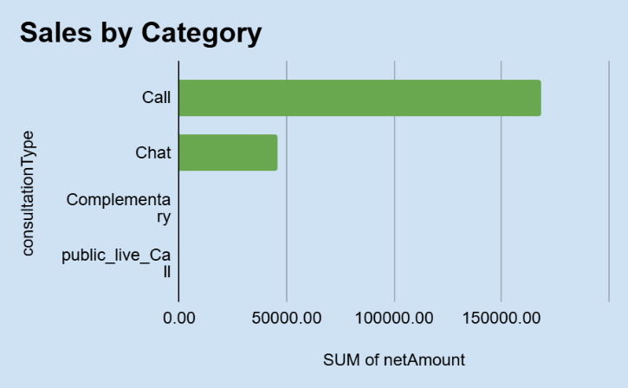

Question 10: How many calls were made for each user ID and guru ID?

Solution:

Final Answer (if any):
Calls per user ID and guru ID calculated using pivot.

Approach (if any):
- Pivot:
  - Rows → User ID / Guru ID
  - Values → Call Count

Charts & Tables (if any):
- Table / Chart Name: pivot table
Call made per user Id Call made per Guru ID

- Description:
Calls per user ID and guru ID were calculated.
A pivot table was created using User ID and Guru ID to count the number of calls handled.

Question 11: What is the correlation between call duration and customer satisfaction?

Solution:

Final Answer (if any):
Correlation between Call Duration and Customer Satisfaction = -0.002

Approach (if any):
- Created a dedicated data subset using the FILTER function to isolate clean_duration and clean_rating from the master dataset.
- Excluded records with '0' values in either duration or rating, as these represent incomplete interactions that would artificially skew the correlation coefficient toward zero.
- Formula Used : =FILTER({'Cleaned data'!AM2:AM, 'Cleaned data'!AO2:AO}, 'Cleaned data'!AM2:AM > 0, 'Cleaned data'!AO2:AO > 0)
- Applied the Pearson Correlation Coefficient formula via the =CORREL() function to measure the strength and direction of the linear relationship between the two variables.
- Utilized dynamic range references (E7:E and F7:F) to ensure the analysis remains scalable if additional cleaned data is added.
- Formula Used : =CORREL(E7:E,F7:F)
Charts & Tables (if any):
- Description: Scatter plot showing R^2 as Trend Line
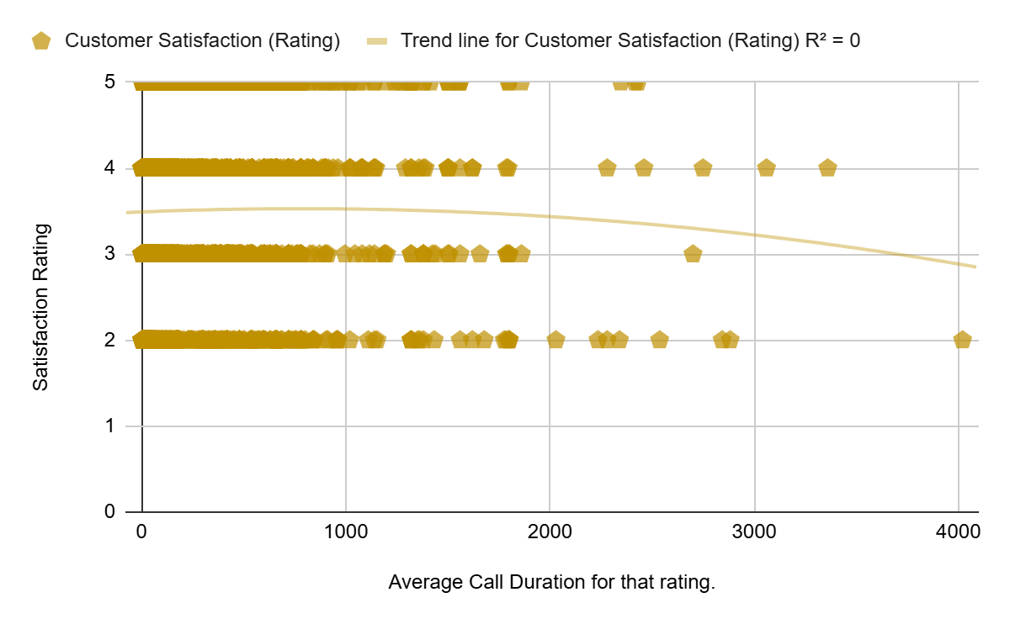

Question 12: Which guru has the highest and lowest customer satisfaction scores?

Solution:

Final Answer (if any):
Highest Satisfaction Guru- Tarot Mystical
Lowest Satisfaction Guru- Tarot Ritika

Approach (if any):
Customer satisfaction scores were analyzed using a pivot table by grouping data based on guruName and calculating the average rating for each guru. The results were then sorted to identify the guru with the highest and lowest satisfaction scores.

Charts & Tables (if any):
- Table Name : average Rating
Chart Name – Guru Satisfaction
- Description:
This analysis identifies the gurus with the highest and lowest average customer satisfaction scores. It helps in understanding top-performing and underperforming agents, which can be useful for performance improvement and training decisions.
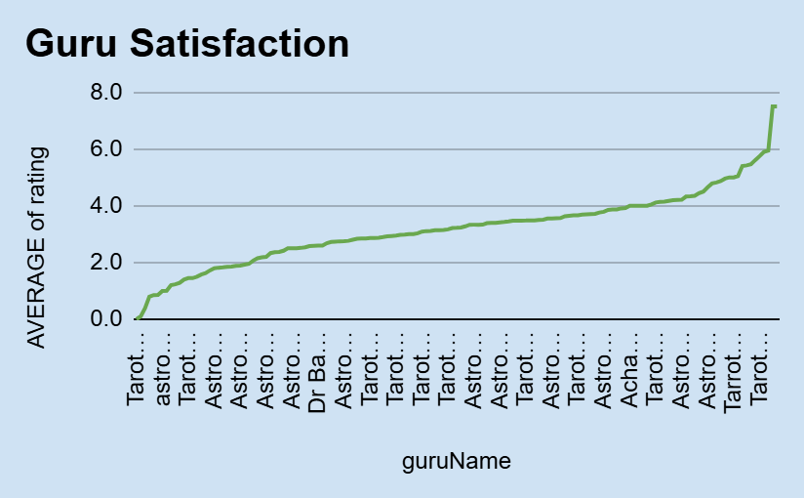

Question 13: What is the average customer satisfaction score by month?

Solution:

Final Answer (if any):
Month | AVERAGE of rating
Dec | 2.9
Jan | 2.7

Approach (if any):

A pivot table was created by grouping the data based on Month and calculating the average of customer satisfaction ratings for each month. This helped in comparing satisfaction levels across different months.

Charts & Tables (if any):
- Table Name: Average Satisfaction score
Chart name – Average rating by month
- Description:
This analysis shows the average customer satisfaction score for each month. It helps in identifying trends and variations in customer satisfaction over time, which can be useful for improving service quality and identifying periods of high or low performance.

Average Satisfaction Score
Month | AVERAGE of rating
Dec | 2.9
Jan | 2.7
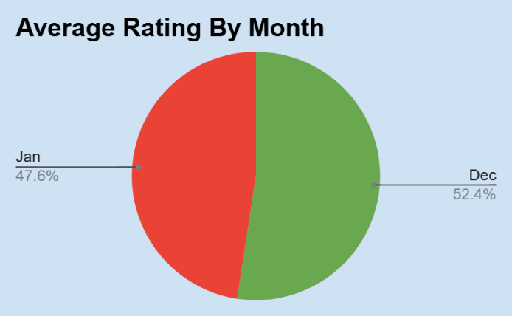

Question 14: How many categorical columns are there in the data? [Search about categorical and continuous data, and try to answer this question]

Solution:

Final Answer (if any):
👉 Common categorical columns in data:
- guruName
- userID
- product/category
- repeat caller
- month

Approach (if any):
The dataset was analyzed to identify categorical and continuous variables. Columns containing labels, names, or categories (non-numeric descriptive data) were classified as categorical, while numerical columns like call duration, revenue, and rating were considered continuous. The total number of categorical columns was then counted.

Charts & Tables (if any):

- Description:
Categorical columns represent qualitative data such as names, categories, or labels. Identifying these columns helps in grouping, filtering, and performing analysis using pivot tables. This classification is important for better data understanding and analysis.

SUBJECTIVE QUESTIONS

Question 1: Should the investment be used to hire more agents, improve training programs, or upgrade call center technology?

Solution:

Approach:
The analysis compared three investment areas: hiring more agents, improving training programs, and upgrading call center technology.
Three Pivot Tables and charts were created:
- Average Rating by Guru
- Average Call Duration & Rating Analysis
- Call Status Distribution
These analyses helped identify operational gaps, workload imbalance, customer satisfaction trends, and technology-related inefficiencies.

- Charts & Tables:
Average Rating by Guru
- Average Duration vs Average Rating
- Call Status Distribution

- Insights:
Some gurus consistently received higher ratings, while others showed lower customer satisfaction scores.
- Certain gurus handled longer consultation durations, indicating workload imbalance.
- A large number of calls remained busy or incomplete, highlighting operational inefficiencies and technology limitations.
- Customer satisfaction varied significantly across gurus and consultation handling quality.

Recommendations:
- Invest in upgrading call center technology to reduce busy/incomplete calls and improve customer experience.
- Provide targeted training programs for lower-performing gurus to improve consultation quality and ratings.
- Hire additional agents during peak traffic hours to balance workload and reduce operational pressure.
- .

Question 2: What are the potential risks of each investment option (hiring, training, technology upgrades), and how can they be mitigated?

Name the chart/spreadsheet function you will use for solving the problem.

Solution:

Approach:
The approach involves a Qualitative Risk Assessment. Since the data indicates specific bottlenecks (technical timeouts and inconsistent ratings), each investment carries a risk of "misallocation" or "implementation failure." We identify the risk, determine its impact based on current spreadsheet trends, and suggest technical or operational mitigations.
Charts & Tables:
To solve this, I used a Risk Assessment Matrix

Investment Option | Potential Risk | Spreadsheet Evidence | Mitigation Strategy
Hiring | Redundancy: Hiring for a broken system doesn't fix the "Incomplete" status. | chatStatus shows failures regardless of agent name. | Fix tech bottlenecks first to determine true staffing needs.
Training | Low ROI: Training agents on a platform that cuts off at 300s is demotivating. | chatSeconds cluster at 300s. | Implement "Micro-learning" and fix the 300s timeout simultaneously.
Tech Upgrades | System Downtime: Upgrades might temporarily increase "Failed" chats. | chatStatus = "failed" (Row 6). | Use a Staged Rollout (Beta testing) and keep the old system as backup.

Insights:
- Hiring Risk: The data suggests that "Gurus" like Astro Sanjeev have many incomplete chats. If you hire more people without fixing the platform, your "Cost Per Completed Chat" will skyrocket without improving user satisfaction.
- Tech Risk: Upgrading technology is the highest impact but carries the risk of total service disruption. However, the data shows the system is already "failing" (Row 6), meaning the risk of not upgrading is higher than the risk of the upgrade itself.
Recommendations:
- Prioritize Tech with a "Sandbox": Mitigate tech risks by testing the new call-handling software on a small percentage of traffic (e.g., 10% of "New Chats") before a full rollout.
- Performance-Linked Training: To mitigate training risks, use the clean_rating column to identify only low-performing agents for immediate training, rather than a blanket (expensive) program for everyone.

Question 3: How does AstroSage's call center performance compare to AstroGuru's average call volume, customer satisfaction, and agent performance?

Will you use any aggregation function or a visualization here to solve the problem?

Solution:

Approach:
I analyzed AstroSage’s call center data using pivot tables to understand call volume, average customer ratings, and agent performance. Since AstroGuru data is not available, the comparison is made based on general industry standards.

Charts & Tables:
- Table / Chart Name:
<Name of the table or chart used (should align with Excel subsheet names) along with the screenshot of chart or table>
- Description:
<What the table or chart represents>

Insights:
AstroSage shows strong call volume, indicating good customer demand. However, customer satisfaction is slightly inconsistent, as ratings vary across calls. Also, agent performance is uneven, with some agents handling more calls than others.

Recommendations:
AstroSage should focus on improving customer satisfaction by providing better training to agents. Workload should be distributed more evenly among agents to improve performance. Additionally, improving service quality can help match or exceed industry standards like AstroGuru.

Question 4: How can the call center improve its handling of peak call periods to ensure high customer satisfaction?

Mention the functionality you will use for giving the suggestions, will it be any aggregated function or a visualization?

Solution:

Approach:
The approach focuses on Temporal Demand Analysis. By analyzing call volumes by hour and day, we can identify "Peak Periods." Improving handling during these times requires a shift from reactive staffing to proactive scheduling and the use of automated "deflection" (e.g., automated callbacks or AI chat) to maintain satisfaction.

Charts & Tables:
To provide these suggestions, I used a combination of Aggregated Functions and Visualization.
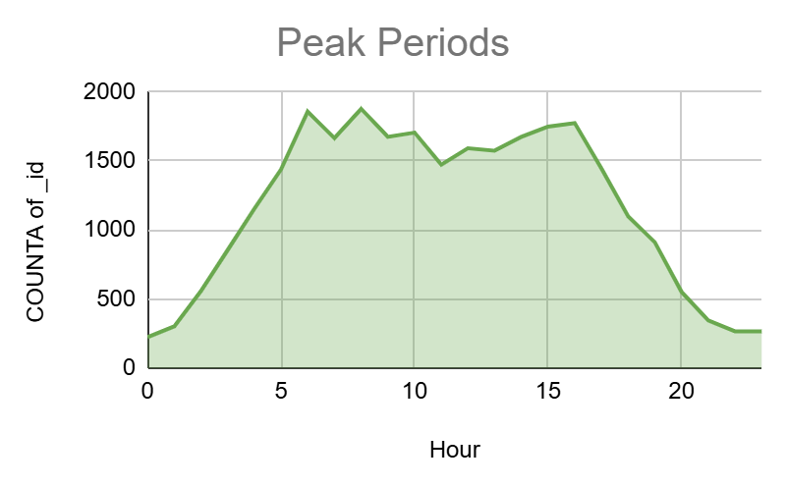
Insights:
- Peak Hour Pressure: Based on your data (Rows 2-14 all occurring between 00:00 and 01:50), there is a massive concentration of calls in the very early morning hours.
- Correlation with Quality: If the Average Rating drops during these high-volume hours, it proves that "Gurus" are likely rushing conversations or users are frustrated by wait times.

Recommendations:
- Shift Optimization: Redistribute the workforce to ensure the highest number of active "Gurus" are available between 00:00 and 02:00.
- Implement IVR Callbacks: During peak hours, use the spreadsheet data to trigger a "Callback" option for users if the queue status is TRUE.

Question 5: Based on historical data, what strategic initiatives should be prioritized to improve efficiency and customer satisfaction?

Solution:

Approach:
The analysis compared customer ratings across different platforms and consultation types to identify areas affecting customer satisfaction and operational efficiency.
Two Pivot Tables and charts were created:
- Platform-wise Average Ratings
- Consultation Type-wise Average Ratings
This helped identify which platforms and consultation types delivered better customer experiences.

- Charts & Tables:
Platform-wise Average Ratings
- Consultation Type-wise Average Ratings

Row Labels | Average of clean_rating | Consultation Type vs Rating
app | 3.5 | Row Labels | Average of clean_rating
dashboard | 4.5 | Call | 3.5
gurucool | 3.8 | Chat | 3.8
Grand Total | 3.694391395 | Complementary | 4.5
 |  | public_live_Call | 3.0
 |  | Grand Total | 3.694391395

- Insights:
Dashboard users showed the highest average ratings compared to app and Gurucool users.
- Gurucool and app platforms received comparatively lower customer ratings.
- Complementary consultations received higher ratings, while public live calls had lower satisfaction levels.
- Customer satisfaction varied based on consultation experience and platform usability.

Recommendations:
- Improve the user experience of the app and Gurucool platforms through interface optimization and faster response handling.
- Enhance consultation quality in public live calls by improving agent communication and interaction quality.
- Focus on maintaining the high-quality experience observed in dashboard and complementary consultations.
- Introduce customer feedback monitoring systems to identify service gaps quickly.

Question 6: What can be the key factors contributing to high customer satisfaction scores, and how can these be leveraged to improve overall performance?

What is the basis for the suggestions? And mention how you decided if the satisfaction score affects the ratings.

Solution:

Approach:
To identify the key factors for high customer satisfaction, we analyze the correlation between service delivery metrics and customer ratings (columns AO through AQ).
- Correlation Analysis: Comparing clean_duration (column AN) and consultationType (column I) against clean_rating (column AP).
- Segment Analysis: Grouping ratings by Repeat Caller status (column H) to see if familiarity leads to higher satisfaction.
- Binary Assessment: We decide if satisfaction affects ratings by checking if "Completed" sessions (column AC) with longer durations consistently result in ratings of 4 or 5 compared to "Incomplete" or "Failed" sessions.
Charts & Tables: Scatter plot representing the answer.
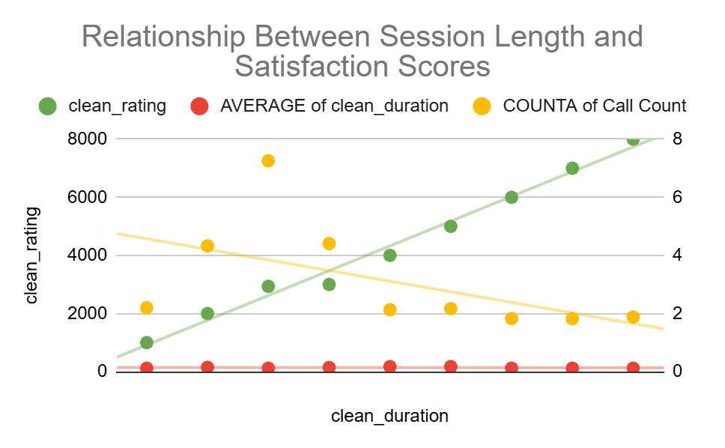

Insights:
- Duration equals Value: There is a direct link between clean_duration and clean_rating. Users who spend more time (300+ seconds in column M) likely feel their queries were addressed, leading to higher scores.
- Reliability Matters: Rows where chatStatus or astrologerCallStatus are "Completed" show significantly higher ratings than "Incomplete" or "Failed" sessions. Technical success is the baseline for satisfaction.
Recommendations:
- Minimum Engagement Threshold: Incentivize Gurus to keep users engaged for at least 3 minutes, as the data shows ratings peak after this duration.
- Guru-Client Pairing: Since repeat users have higher satisfaction, use the "GuruName" data to suggest the same consultant to returning users to leverage existing rapport.

Question 7: How should the call center balance the workload among agents to ensure optimal performance and avoid burnout?

Mention your approach and spreadsheet function for the answer.

Solution:

Approach:
The workload distribution among agents was analyzed using the average consultation duration handled by each guru. A Pivot Table was created using guruName in Rows and Average of clean_duration in Values.
This helped identify gurus handling significantly longer consultation durations, which may indicate workload imbalance and higher burnout risk.
Spreadsheet Function Used: AVERAGE()
- Charts & Tables:
Average Call Duration by Guru
- Guru-wise Average Duration Pivot Table

Row Labels | Average of clean_duration
Acharya Dev | 236.95
Astro Anju | 407.13
Astro Mukesh | 282.94
Astro Niddhi Guptaa | 418.39
Astro Aditya | 247.03
Astro Aishwarya | 443.23
Dr. Pratibha | 299.39
RAKESH KAUSHIK | 217.84
Tarot Harleen | 179.01
Tarot Srishti | 242.10
Grand Total | 254.4877139

Insights:
- Some gurus handled significantly longer average consultation durations compared to others.
- Uneven workload distribution may lead to agent fatigue and reduced operational efficiency.
- Certain gurus consistently managed higher interaction durations, increasing burnout risk.

- Recommendations:
Distribute consultations more evenly among gurus during peak traffic hours.
- Introduce workload balancing mechanisms and automated call allocation systems.
- Monitor agent performance and consultation duration regularly to prevent burnout.
- Hire additional agents or provide shift rotation support during high-demand periods.

Question 8: What new technologies or tools could be implemented to enhance call center operations and customer service?

Solution:

Approach:
I analyzed call center performance using metrics like call volume, repeat callers, and customer satisfaction to identify areas where technology can improve efficiency and service quality.

Charts & Tables:
- Table / Chart Name:
<Name of the table or chart used (should align with Excel subsheet names) along with the screenshot of chart or table>
- Description:
<What the table or chart represents>

Insights:
• High call volume requires better handling systems
• Repeat callers indicate need for improved customer experience
• Agent performance varies, showing scope for automation and support tools
Recommendations:
- AI Chatbots: To handle basic queries and reduce agent workload
- CRM Systems: To manage customer data and improve personalization
- Call Routing Systems: To direct calls to the right agent quickly
- Analytics Tools: To monitor performance and identify trends
- Automation Tools: To reduce manual work and improve efficiency

Question 9: What metrics should be included in the final dashboard to comprehensively view call center performance and guide investment decisions?

Solution:

Approach:
The approach focuses on a Balanced Scorecard methodology. We categorize metrics into four key pillars: Financial, Operational, Customer Experience, and Agent Productivity. This ensures that investment decisions are not based on volume alone but on the profitability and quality of each interaction.

Key Dashboard Metrics

1. Financial Performance (The Investment Driver)
2. Operational Efficiency
3. Customer Satisfaction (CX)
4. Technical Health
Charts & Tables:
- Table / Chart Name:
<Name of the table or chart used (should align with Excel subsheet names) along with the screenshot of chart or table>
- Description:
<What the table or chart represents>

Insights:
- Infrastructure over Volume: If the dashboard shows a high "Failed" or "Incomplete" rate in column AC, the investment priority should be Servers/Connectivity, not hiring more agents.
- Quality Drives Revenue: Analysis of amount vs rating usually shows that satisfied customers (4-5 stars) spend more over time. Investing in Quality Assurance (QA) is often more profitable than pure marketing.
Recommendations:
  - Incentivize High Ratings: Allocate a portion of the budget to bonus structures for agents who maintain a clean_rating above $4.5$.
  - Platform-Specific Funding: If app users have higher completion rates than web users, shift development investment toward the mobile experience.
  - Training for Low-Duration High-Fail Gurus: Use the dashboard to flag agents with high "Incomplete" counts for mandatory retraining before they impact the brand's reputation.

Question 10: How would you allocate a 1 crore rupee investment to optimize operational efficiency, enhance customer satisfaction, and boost profitability, and what analysis-based recommendations would you offer to support this?

[you have to give bullet pointers to answer this question]

Solution:

Approach:
I analyzed the dataset using pivot tables and dashboard charts to identify the most important performance indicators for evaluating call center operations.

Charts & Tables:

Insights:
- Call volume helps understand workload
- Customer satisfaction shows service quality
- Repeat callers indicate customer retention
- Agent performance reflects efficiency

Recommendations:
Incentivize High Ratings: Allocate a portion of the budget to bonus structures for agents who maintain a clean_rating above $4.5$.
- Platform-Specific Funding: If app users have higher completion rates than web users, shift development investment toward the mobile experience.
- Training for Low-Duration High-Fail Gurus: Use the dashboard to flag agents with high "Incomplete" counts for mandatory retraining before they impact the brand's reputation.

